Internet Fundamentals - Subnetting Prac 2

# 

Part 1 - VLSM 1

Task 1. 3

Task 2. 4

Part 2 - Supernetting 5

Task 3. 6

Task 4. 6

# Part 1 - VLSM

In last week’s prac we looked at basic subnetting, where all subnets created have the same size. Generally, however, we have different size requirements for our different subnets, so the basic approach can lead to a lot of waste, especially when creating subnets for WAN links. VLSM (variable length subnet masks) allow us to create subnets of varying sizes from one block of addresses.

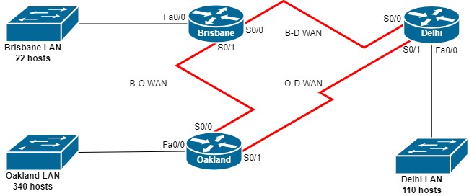

Suppose we have the above network, and we are given the class B block 175.175.0.0/16 to use. How should we create our subnets? The simplest approach is to arrange the required subnets in descending order of size and then create the subnets beginning at the start of our class B block.

|  |  |  |  |  |  |
| --- | --- | --- | --- | --- | --- |
| Subnet | Hosts | Size | Host bits | Subnet address | Broadcast address |
| Oakland LAN | 340 | 512 | 9 |  |  |
| Delhi LAN | 110 | 128 | 7 |  |  |
| Brisbane LAN | 22 | 32 | 5 |  |  |
| Brisbane – Delhi WAN | 2 | 2 | 1 |  |  |
| Delhi – Oakland WAN | 2 | 2 | 1 |  |  |
| Oakland – Brisbane WAN | 2 | 2 | 1 |  |  |

To determine the necessary size, we consider the next power of 2 larger than the number of hosts. Even if the number of hosts is already a power of 2, we need to use the next largest size, as we can’t use the first or last addresses as host addresses. Recall that if a subnet has size 2*H*, then we need *H* bits for the host part of the address. So, for the Lagos LAN we need a subnet of size 512, and because 29 = 512, we need 9 host bits for this subnet. 9 host bits means 32 - 9 = 23 network bits, so our subnet mask will be /23.

|  |  |  |  |  |  |
| --- | --- | --- | --- | --- | --- |
| Subnet | Hosts | Size | Host bits | Subnet address | Broadcast address |
| Oakland LAN | 340 | 512 | 9 |  |  |
| Delhi LAN | 110 | 128 | 7 |  |  |
| Brisbane LAN | 22 | 32 | 5 |  |  |
| Brisbane – Delhi WAN | 2 | 4 | 2 |  |  |
| Delhi – Oakland WAN | 2 | 4 | 2 |  |  |
| Oakland – Brisbane WAN | 2 | 4 | 2 |  |  |

Now we need to determine the subnet addresses and masks. The Oakland LAN comes first, so its subnet address will be 175.175.0.0/23. We know that the last address will 175.175.1.255/23 (because we have 512 addresses) and this is the broadcast address. We then create the Delhi LAN subnet beginning at the next address: 175.175.2.0.

|  |  |  |  |  |  |
| --- | --- | --- | --- | --- | --- |
| Subnet | Hosts | Size | Host bits | Subnet address | Broadcast address |
| Oakland LAN | 340 | 512 | 9 | 175.175.0.0/23 | 175.175.1.255/23 |
| Delhi LAN | 110 | 128 | 7 | 175.175.2.0/25 | 175.175.2.127/25 |
| Brisbane LAN | 22 | 32 | 5 | 175.175.2.128/27 | 175.175.2.159/27 |
| Brisbane – Delhi WAN | 2 | 4 | 2 | 175.175.2.160/30 | 175.175.2.163/30 |
| Oakland – Brisbane WAN | 2 | 4 | 2 | 175.175.2.164/30 | 175.175.2.167/30 |
| Delhi – Oakland WAN | 2 | 4 | 2 | 175.175.2.168/30 | 175.175.2.171/30 |

Now that we have our subnets, we need to determine the addresses for each of the router interfaces we are using. For router interfaces on a LAN or WLAN, generally the first usable host address will be allocated. For WANs, the interface of one router will receive the first usable address, and the other router will receive the second usable address. For the WANs, we will allocate the first address to whichever router appears higher in the diagram, and if they are the same height, the leftmost router. However, this choice is arbitrary, and either interface may be allocated the first address.

|  |  |  |
| --- | --- | --- |
| Router | Interface | Address |
| Brisbane | Fa0/0 (Brisbane LAN) | 175.175.2.129/27 |
| S0/0 (B-D WAN) | 175.175.2.161/30 |
| S0/1 (B-O WAN) | 175.175.2.165/30 |
| Delhi | Fa0/0 (Delhi LAN) | 175.175.2.1/25 |
| S0/0 (D-B WAN) | 175.175.2.162/30 |
| S0/1 (D-O WAN) | 175.175.169/30 |
| Oakland | Fa0/0 (Oakland LAN) | 175.175.0.1/23 |
| S0/0 (O-B WAN) | 175.175.2.166/30 |
| S0/1 (O-D WAN) | 175.175.170/30 |

Continue to **Task 1** on the next page.

## Task 1.

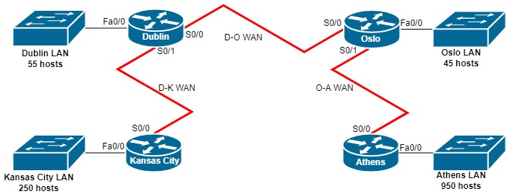

Given the above network, and the class B block 183.200.0.0/16, fill out the table of subnets below, and then allocate addresses to the router interfaces.

|  |  |  |  |  |  |
| --- | --- | --- | --- | --- | --- |
| Subnet | Hosts | Size | Host bits | Subnet address | Broadcast address |
| Athens LAN | 950 | 1024 | 10 | 183.200.0.0/22 | 183.200.4.255/22 |
| Kansas City LAN | 250 | 256 | 8 | 183.200.5.0/24 | 183.200.5.255/24 |
| Dublin LAN | 55 | 64 | 6 | 183.200.6.0/26 | 183.200.6.63/26 |
| Oslo LAN | 45 | 64 | 6 | 183.200.6.64/26 | 183.200.6.127/26 |
| Dublin - Kansas City WAN | 2 | 4 | 2 | 183.200.6.128/30 | 183.200.6.131/30 |
| Dublin - Oslo WAN | 2 | 4 | 2 | 183.200.6.132/30 | 183.200.6.135/30 |
| Oslo - Athens WAN | 2 | 4 | 2 | 183.200.6.136/30 | 183.200.6.139/30 |

|  |  |  |
| --- | --- | --- |
| Router | Interface | Address |
| Dublin | Fa0/0 (Dublin LAN) | 183.200.6.1/26 |
| S0/0 (D-K WAN) | 183.200.6.129/30 |
| S0/1 (D-O WAN) | 183.200.6.133/30 |
| Oslo | Fa0/0 (Oslo LAN) | 183.200.6.65/26 |
| S0/0 (O-D WAN) | 183.200.6.134/30 |
| S0/1 (O-A WAN) | 183.200.6.137/30 |
| Kansas City | Fa0/0 (Kansas City LAN) | 183.200.5.1/24 |
| S0/0 (K-D WAN) | 183.200.6.130/30 |
| Athens | Fa0/0 (Athens LAN) | 183.200.0.1/22 |
| S0/0 (A-O LAN) | 183.200.6.138/30 |

## Task 2.

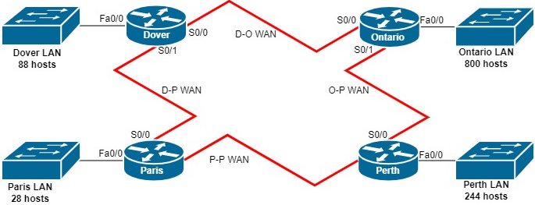

Given the above network, and the class B block 137.101.0.0/16, fill out the table of subnets below. Remember to order by descending size!

|  |  |  |  |  |  |
| --- | --- | --- | --- | --- | --- |
| Subnet | Hosts | Size | Host bits | Subnet address | Broadcast address |
| Ontario LAN | 800 | 1024 | 10 | 137.101.0.0/22 | 137.101.4.255/22 |
| Perth LAN | 244 | 256 | 8 | 137.101.5.0/24 | 137.101.5.255/24 |
| Dover LAN | 88 | 128 | 7 | 137.101.6.0/25 | 137.101.6.127/25 |
| Paris LAN | 28 | 32 | 5 | 137.101.6.128/27 | 137.101.6.159/27 |
| Dover - Ontario WAN | 2 | 4 | 2 | 137.101.6.160/30 | 137.101.6.163/30 |
| Dover - Paris WAN | 2 | 4 | 2 | 137.101.6.164/30 | 137.101.6.167/30 |
| Ontario - Perth WAN | 2 | 4 | 2 | 137.101.6.168/30 | 137.101.6.171/30 |
| Paris - Perth WAN | 2 | 4 | 2 | 137.101.6.172/30 | 137.101.6.175/30 |

|  |  |  |
| --- | --- | --- |
| Router | Interface | Address |
| Dover | Fa0/0 (Dover LAN) | 137.101.6.1/25 |
| S0/0 (D-O WAN) | 137.101.6.161/30 |
| S0/1 (D-P WAN) | 137.101.6.165/30 |
| Ontario | Fa0/0 (Ontario LAN) | 137.101.0.1/22 |
| S0/0 (O-D WAN) | 137.101.6.162/30 |
| S0/1 (O-P WAN) | 137.101.6.169/30 |
| Paris | Fa0/0 (Paris LAN) | 137.101.6.129/27 |
| S0/0 (P-D WAN) | 137.101.6.166/30 |
| S0/1 (P-P WAN) | 137.101.6.173/30 |
| Perth | Fa0/0 (Perth LAN) | 137.101.5.1/24 |
| S0/0 (P-O WAN) | 137.101.6.170/30 |
| S0/1 (P-P WAN) | 137.101.6.174/30 |

# Part 2 - Supernetting

Supernetting (aka address or route summarisation) allows us to combine nearby subnet addresses into a single address to reduce the size of routing tables, or to create a larger network out of contiguous class B blocks.

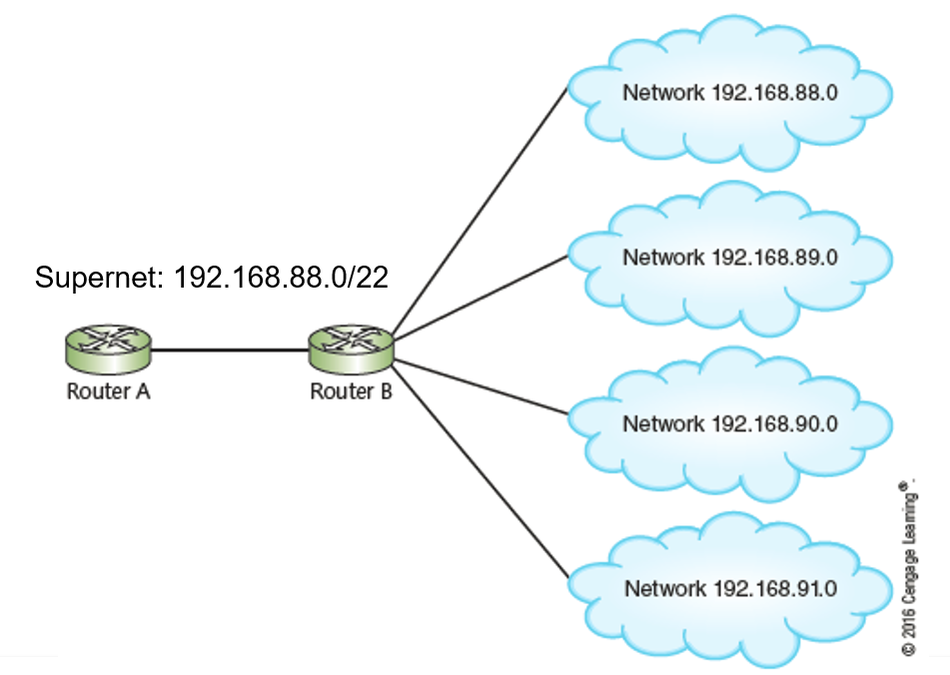

To determine the supernet address and mask, we need to look at the binary for the dissimilar octet for each of the networks we’ll be combining. Let’s determine the supernet for the following:

* 223.101.64.0/24
* 223.101.66.0/24
* 223.101.67.0/24
* 223.101.68.0/24

|  |  |
| --- | --- |
| Dissimilar octet | Convert to binary and determine common bits |
| 64 | 01000000 |
| 66 | 01000010 |
| 67 | 01000011 |
| 68 | 01000100 |

We take the common bits and fill the rest with zeros to obtain 01000000 = 64, so our supernet address is 223.101.64.0. Because we have 5 common bits among the dissimilar octets, and 16 common bits from the two similar octets, the mask is 16 + 5 = 21.

So overall our supernet is 223.101.64.0/21.

## Task 3.

Determine the supernet for

* 223.101.135.0/24
* 223.101.138.0/24
* 223.101.140.0/24
* 223.101.141.0/24

|  |  |
| --- | --- |
| Dissimilar octet | Convert to binary and determine common bits |
| 135 | **1000**0111 |
| 138 | **1000**1010 |
| 140 | **1000**1100 |
| 141 | **1000**1101 |

The superset is 223.101.128.0/20

(Hint: the address is not 223.101.135.0)

## Task 4.

Determine the supernet for

* 223.101.200.0/22
* 223.101.204.0/22
* 223.101.208.0/22
* 223.101.212.0/22

|  |  |
| --- | --- |
| Dissimilar octet | Convert to binary and determine common bits |
| 200 | **110**01000 |
| 204 | **110**01100 |
| 208 | **110**10000 |
| 212 | **110**10100 |

The superset is 223.101.192.0/19